RODBOROUGH MANOR (HILL HOUSE)
Summary
There are records for the Hill House (initially known as Hill Living) estate going back at least to 1651. It changed hands several times before being bought in 1757 by Woodchester clothier Sir Onesiphorus Paul who built a new villa there. His son, also Onesiphorus, inherited both the business and the estate in 1774 (he adopted the first name George in 1780). Sir George, who became a key penal reformer, made major alterations to the house and grounds in 1784-92. The house descended within the family until sold in 1854 and went through several more hands (including those of Lord John Russell, later Prime Minister) before being bought by the clothier Sir William Marling in 1889; Marling’s S S Marling son was the owner in 1906 when the house was burnt to a shell. The house was then left to decay until 1922 when the central part of the main front was rebuilt on a much smaller scale by egg incubator manufacturer E Lee Godfrey. A new second dwelling based on the west side of the house was created in 1952 and the coach and stable block has also been developed into a single dwelling. However, the late C18 landscaped park, with its winding woodland walk and eyecatcher Gothick archway, survives, as does a fountain pool within the domestic curtilage.
The House
Fig 1 shows the house as offered for sale in 1889. The central 5 bays may have been formed from Sir O Paul’s original villa, and the wings added as part of Sir George’s campaign of 1784-92 when he employed architect Anthony Keck. The wide stone portico was added later either by him or by his nephew who inherited in 1820.
Internally, the main entrance gave access to an entrance hall extending the full width of the 5 bay centre (nearly 50ft), with a pair of elaborate marble chimneypieces, plasterwork overmantels and overdoors and a fine dentilled ceiling cornice – possibly surviving from Sir G Paul’s time. Behind the hall was a top-lit cantilevered stone stair, rising in a semicircle around a large alcove, the walls and ceiling of which were decorated with chaste plasterwork and apparently painted allegorical scenes. The principal Georgian rooms were, to either side of the hall, the dining and drawing rooms. The drawing room had a fine marble chimneypiece, leading to two more reception rooms along the west front: a music room (dominated by a large semi-circular alcove containing the fireplace and statuary niches) and a library.

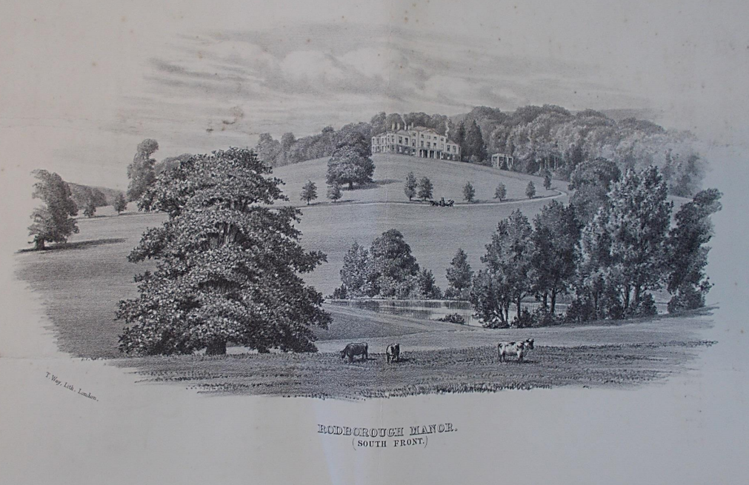
Fig 1: Rodborough Manor in 1889 (Gloucestershire Archives)

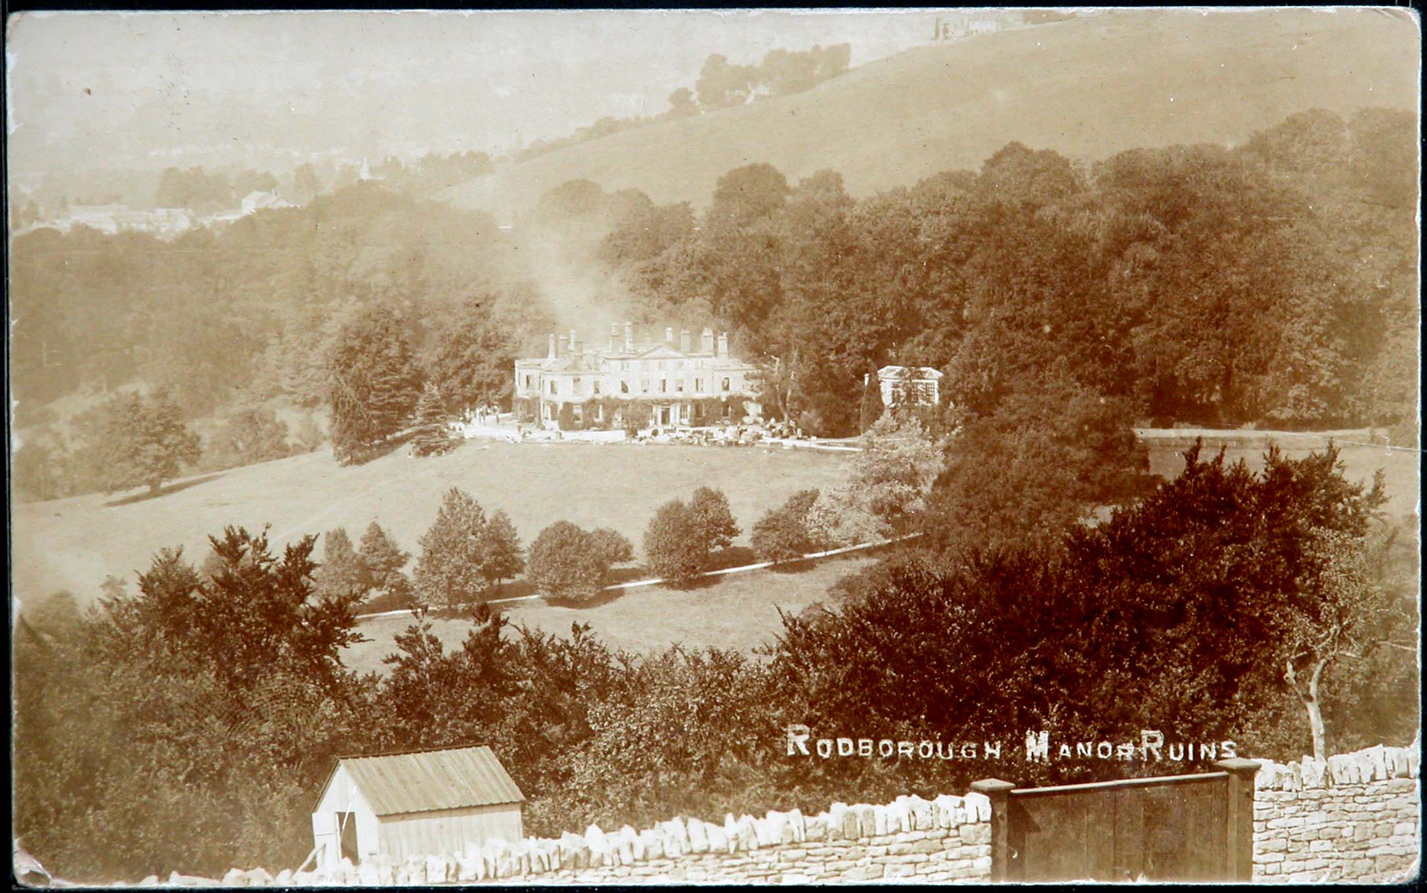
Fig 2: Rodborough Manor after the 1906 fire (Howard Beard)

The Ornamental Gardens
The house faces south with a commanding view of the small valley immediately to the south, containing the pastureland park and a large fishpond, and - to the west – of the Nailsworth valley (running north-south) and the Woodchester valley beyond it. A terrace sweeps round in front of these two sides of the house to take advantage of these views.
Detail of the ornamental gardens is sparse. Sir George’s library catalogues include a number of books on gardening, forestry and botany (as well as Uvedale Price’s An Essay on the Picturesque}. But the terrace area is quite compact and the mansion, stables and other outbuildings, woodland and park leave limited additional room to the north for ornamental gardens either at the time of the 1839 tithe map [Fig 9] or the 1855 sale [Fig 10] (when the particulars refer to “exceedingly beautiful” pleasure grounds with “a choice variety of shrubs”). A terraced garden has been created since 1994 north of the house and immediately to the west of the drive shown in the 1882 OS 25” map [Fig 7]: during its construction, evidence of Cotswold stone walling indicated an earlier terraced garden had existed on the same site but this is not shown on available maps – it might possibly date from the Lee Godfreys’ day.
Nicholas Kingsley refers to the 45ft long stone conservatory (visible to the right of the house in both the 1889 engraving and a 1906 postcard [Figs 1 and 2]) as “early 19th century” but the first evidence for it is in the 1855 sale particulars – it is missing from the tithe map, which shows other outbuildings. Agnes Witts, who with her husband rented nearby Bownham Park in the 1790s, records in her diary various visits to the Pauls. Although a keen gardener who spent much time in her own conservatory at Bownham Park, she makes no mention of a conservatory at Hill House (and indeed she is silent as to its ornamental gardens).
The 1885 OS map shows a fountain (also referred to in the 1870 sale particulars) in front of the conservatory. The circular fountain pool survives, together with a (possibly not original) fountain in the form of a cherub. A design by Sir John Dean Paul survives which may be of the original fountain, in which case it can be dated to 1847-52. The conservatory appears to have been demolished at some point between 1921 and 1938.
The 1855 particulars refer to an icehouse “near the conservatory”, possibly one of the three small outbuildings shown to the NE of the house on the OS 25” map but none of these survive.
The same particulars also emphasise that a “very strong and expensive open iron fence” divided the gardens from the park (this survives in good condition).

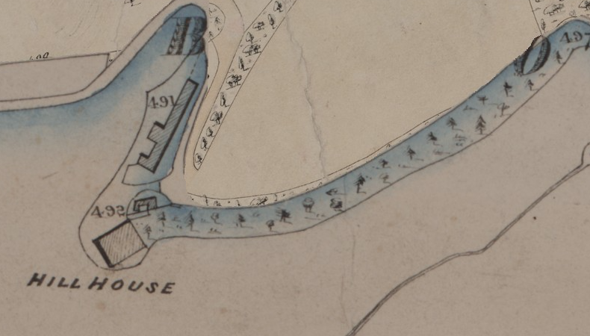
Fig 9: Detail of 1839 tithe map (Gloucestershire Archives)
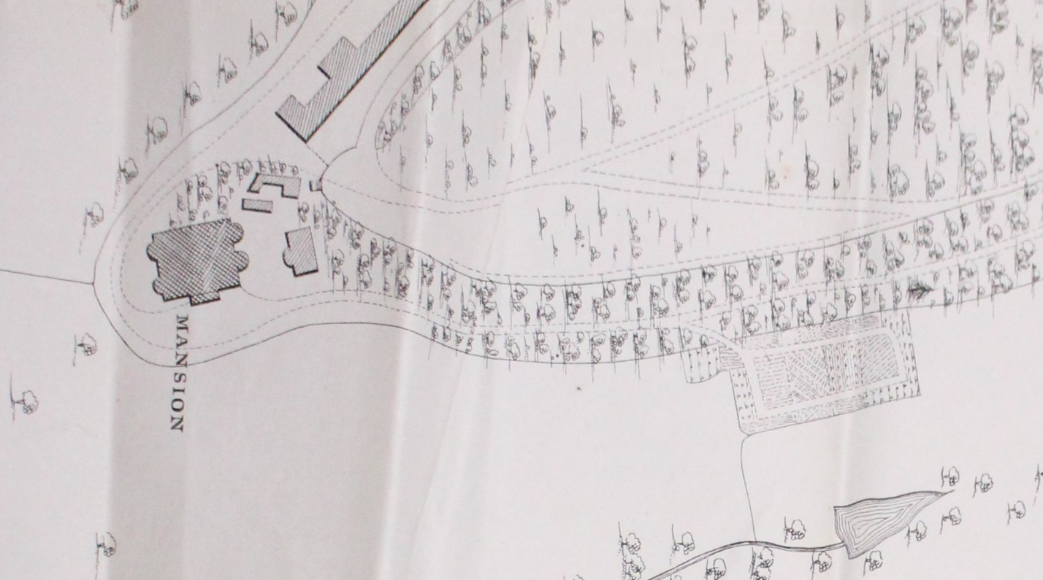
Fig 10: Detail of plan in 1855 sale particulars, showing conservatory to east of house and site of the old kitchen garden (Gloucestershire Archives)

The Park
The park lies to the west and south of the house and retains extensive evidence, much of it readily visible on the ground today, of medieval cultivation.
Sir George planted a shelter belt on the eastern perimeter of the park and created a winding walk within it. Horse and footway diversions were secured which gave greater privacy for the walk in 1788 and a substantial dry stone bridge to carry the public track which ran across the park (now public footpath MH2) over the walk which drops under it. Sale particulars of 1855 describe the walk as “dry and shady.. opening at various points to cheerful views of the opposite hills and other pleasing scenery.”
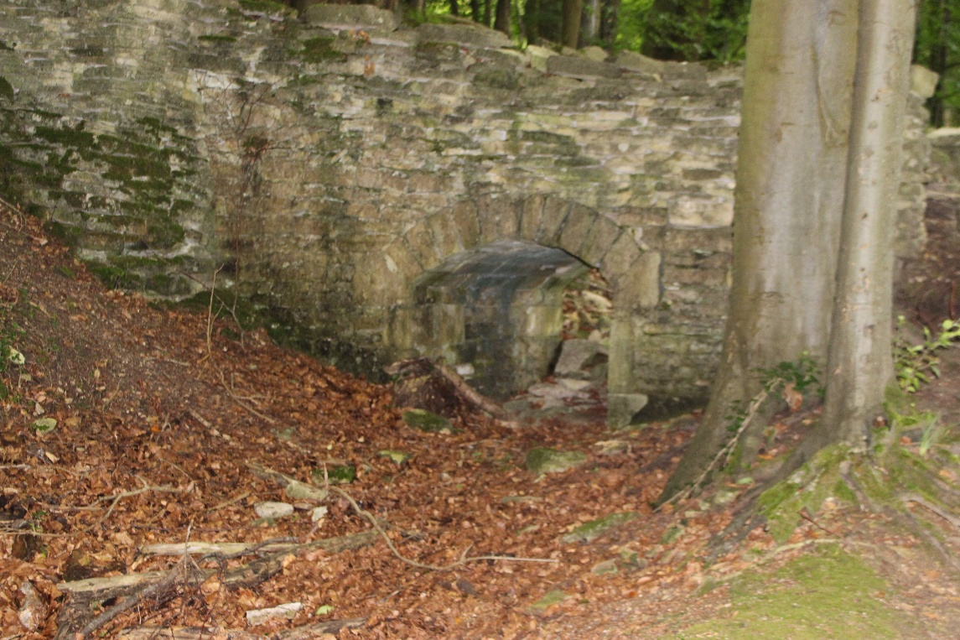
Fig 4: Bridge carrying public track over the walk (The author)
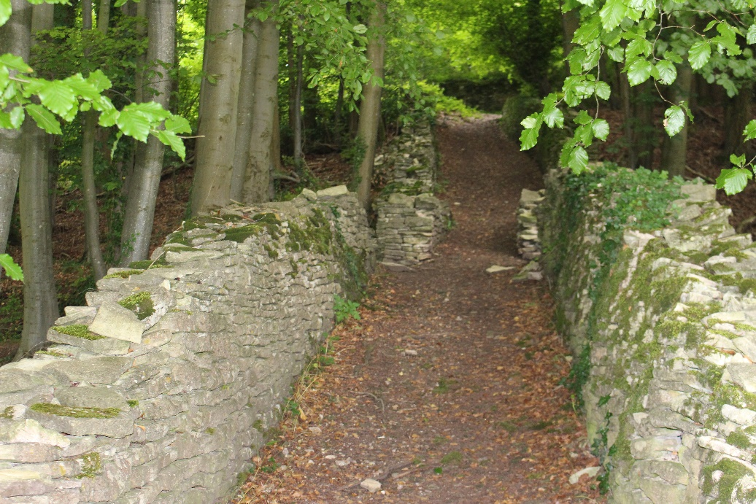
Fig 5: Walls of track over the bridge (recent breaks have been made in the walls to facilitate passage parallel to the walk which is silted up under the bridge) (The author)
The walk leads to a Gothick eyecatcher (architect unknown; designed to be seen, in a break in the treeline, across the park from the house) consisting of two round towers joined by a wide, originally open arch with crenellated parapet. Fig 6 shows the building after its conversion into a house, when the arch opening was completely blocked in. There is no sign of any track ever having led through the arch, but this photo suggests that there may have been some form of terrace in front of it.
Agnes Witts (see above) records that on 26 June 1791, she joined the Pauls and other guests: “All walk’d to the Towers & back again” – implying that the folly was a destination point rather than part of a circular route. Although this suggests that Sir George himself may have called the building The Towers, it has been known by various names, including The Hermitage, The Castle, The Amberley Eyecatcher and The Gateway (the name used in the Grade II listing).
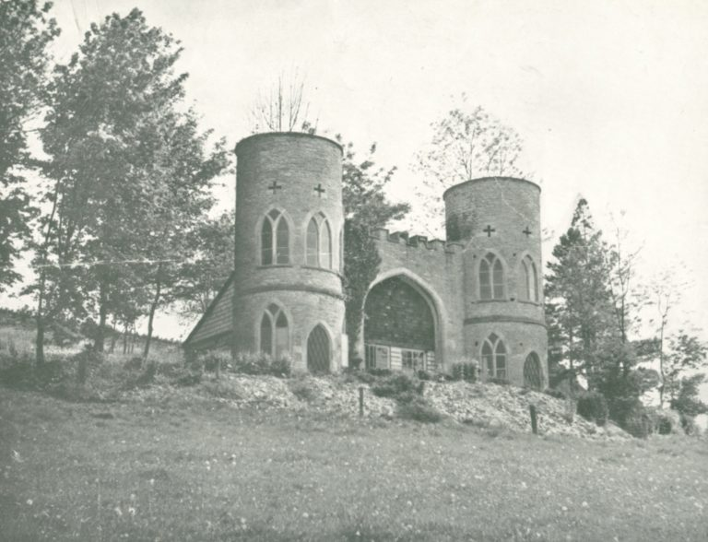
Fig 6: The Gateway (after its conversion to a house) (Minchinhampton Local History Group)
Sale particulars dated 1855 show the walk leading directly from Hill House but the initial section is now blocked by Spinney Bank (formerly The Bungalow) built c.1959. Annex B to this report shows the route of the walk and 2021 public rights of way: The first section can be easily viewed by following the parallel bridleway MRO73 (accessed from immediately east of the entrance to Rodborough Manor on Bear Hill); once past Spinney Bank, public access along the walk itself appears to be tolerated and further along the walk has been adopted as bridleway MMH182 and continues as such up to the curtilage of The Gateway.
At some point between 1870 and 1882 when the OS 25” map was surveyed a new drive was constructed across the park from the Bath Road (A46) and a new lodge built. The lodge survives but the drive was abandoned after the 1906 fire.
.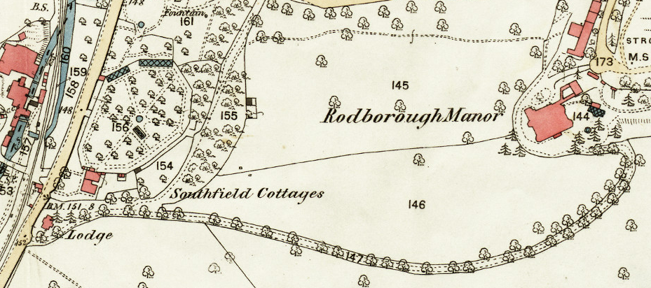
Fig 7: OS 25” map (surveyed 1882), showing “new” kitchen garden and recently constructed drive and lodge (Gloucestershire Archives)
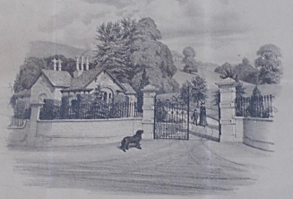
Fig 8: New lodge (William Clissold), c1882.(Gloucesershire Archives)
The Kitchen Garden
The 1855 particulars state that “The old vegetable gardens having been given up, new gardens [on a polygonal site by the turnpike at the extreme west of the park] have recently been made which at present are only in an improving state”. This suggests slow progress as the “new” kitchen gardens (1.67 acres) are also shown on the 1839 tithe map, whereas the abandoned kitchen garden, shown on the 1855 particulars to the east of the house, was thought unworthy of including on the 1839 map (compare Figs 9 and 10). But by the time of the further sale in 1870, the “productive” kitchen garden “completely surrounded by a brick wall” is “well stocked with choice fruit trees, forcing pits, greenhouse, tool house &c &c”.
After the house burned down in 1906, the kitchen garden was probably abandoned and when E Lee Godfrey acquired the Rodborough Manor estate in 1922 he built a factory within the walls for making egg incubators. After his death in 1935, the facility was used by a series of other industrial companies. Finally in 1995, the high brick walls were reduced in height and 11 houses built within them (Manor Gardens).
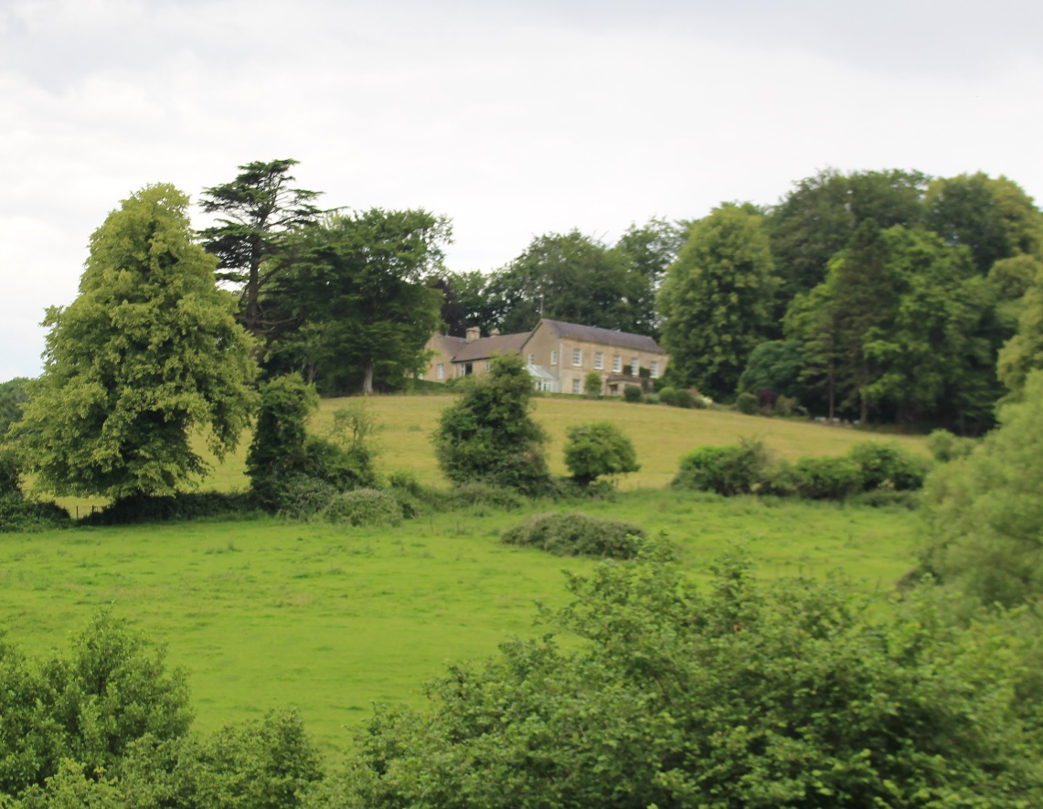
Fig 11: Rodborough Manor as rebuilt c1923 (The author)
Principal Owners
Sir Onesiphorus Paul (1706-1774) came from a local clothier family. He invented and implemented several improvements in the dying and finishing of cloth at his Woodchester Southfield Mill and became one of the leading local clothiers. In 1750 he entertained the Prince of Wales, ten years later as high sheriff of the county he presented a loyal address on the king’s accession, which brought him a knighthood and he was made a baronet in 1762. His social aspirations were lampooned: “Sir Onesiphorus Paul and his Lady are the finest couple that have ever been seen since Bath was built. They have bespoke two whole-length pictures, which some time or another will divert us. His dress and manner are beyond my painting; however, they may come within Mr Gainsborough’s.”
His son Sir George Onesiphorus Paul (1746-1820) went to St John’s College, Oxford, and on to the Grand Tour. On inheriting, he leased Southfield Mill to his cousin Obadiah Paul and settled down to a comfortable bachelor life (he never married) as landed proprietor. He kept a good cellar and built up a picture collection. Like his father, he spent time as high sheriff but is most remembered for his work on reform of criminal justice, prisons and the care of lunatics. He also courted royalty and entertained George III at Hill House in 1788 when the latter visited Southfield Mill. His prison reform work attracted the attention of Sir Walter Scott, whom he accompanied on a journey to the Hebrides in 1810. The estate remained in the Paul family until 1854.
Lord John Russell (1792-1878) bought the estate in 1855 from Thomas Marling who had bought it from the Paul family the year before. Russell was a former MP for Stroud (1834-41) had a long political political career, noteworthy for the number of resignations from high office on matters of principle. As home secretary in 1837 he reduced the number of offences subject to capital punishment and he was later colonial and foreign secretary and finally (1865-66) prime minister. He however did not live in Rodborough Manor himself after 1856 (the house being first let out and then occupied by his son).
The Paul family reacquired the estate in 1871 but sold it in 1889 to clothier Sir William Marling of Kings Stanley, whose son Samuel Stanley Marling was living in the house when it burned down in 1906. The latter sold the estate to a Charles Apperley in 1917 but he got into financial difficulty and his bank repossessed it before selling to E Lee Godfrey in 1922. He died in 1935, having rebuilt the house on a smaller scale, and in 1937 his widow Blanche gave the Rodborough Common land beyond the northern curtilage of the park to the National Trust,/ After the war she sold part of the site of the house to enable the building of a second dwelling and sold off the stables for conversion to a residence (now a single dwelling but at one point divided into five flats) which confusingly became known as the Manor House.
Thoss Shearer
Gloucestershire Gardens & Landscape Trust
July 2021, updated October 2021
The author is indebted to the following for information and/or access to the site: Howard Beard, Derek Bees, Jane Bradney, Fred Hiscox and Ian Roberts

ANNEX A: THE GATEWAY

Historic England Listing: Grade II
List Entry Number:1340485
Date first listed: 28 Jun 1960
Eyecatcher folly, converted into house. Late C18, for Sir George Onesiphorus Paul. Random thin-bedded rubble limestone. Two round 2-storey towers with gateway between. Three stone Y-traceried pointed arched Gothick windows to upper floor of each tower, 2 below either side of pointed doorway with lattice- patterned door. Cross slits in high parapets to towers, quatrefoils at higher level. Flat roofs to towers. Linking wall with crenellated parapet has large 4-centred archway, now with recessed C20 infill. C20 lean-to concrete block built addition to rear is not of special interest. Built to be seen against wooded back-drop from Sir George's Rodborough Manor, situated on opposite side of small valley. (B.Jones, Follies and Grottoes, 1974; and D. Verey, Gloucestershire: The Cotswolds, 1979.

ANNEX B: C18 WALK AND MODERN RIGHTS OF WAY
The walk starts by Spinney Bank (built over an original section of the walk) and is shown by a black line until absorbed by the blue line indicating Bridleway MMH182. Basemap is the online Gloucestershire Public Rights of Way map (https://maps.gloucestershire.gov.uk/MapThatPublic/Default.aspx, accessed 29 July 2021)
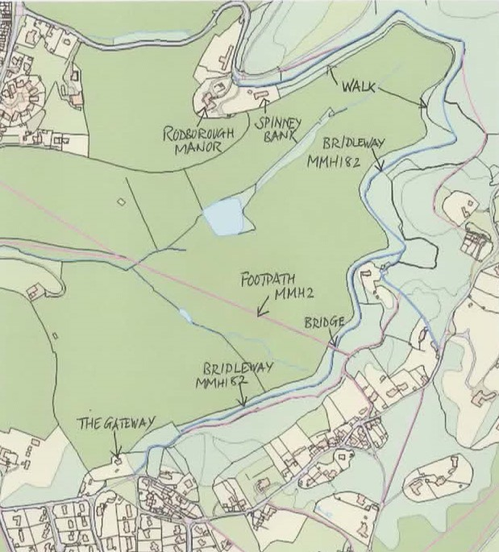

VCH Gloucestershire, Vol XI (1976) p.223; the discussion of preceding estates is continued in Martin Eccleston, The Location of two Medieval Properties in Rodborough (Glevensis 33, 2002, pp.29-36).
VCH, op.cit, p.224, reports that according to the then (1976) current owner materials from the old house incorporated into the new included a mid C18 marble fireplace and a Paul coat of arms formerly on the south front pediment.
1889 sale particulars (Gloucestershire Archives (GA) D4335/167. These particulars appear to be the first use of the house/estate name Rodborough Manor, rather than Hill House, although Sir George had purchased the manorship in 1806 (VCH, op.cit, pp.223-234).
Account books (GA, D589/Box F) detail expenditure of over £7,000 on improving the house and grounds in this period.
There is a full description of the house in Nicholas Kingsley, The Country Houses of Gloucestershire: Volume Two 1660-1830 (1982), pp.212-214, largely based on the 1889 particulars, and I have simply condensed that account. Nicholas Kingsley posits there that Sir O Paul’s villa may also have been Anthony Keck’s work, in which case it would be one of his earliest commissions. A small representation of the house in Plate III of Samuel Lysons’s An Account of Roman Antiquities Discovered at Woodchester (1797) appears to show that only the SW wing had been added when the view was drawn. Either the wings owed their final form to early C19 changes which echoed the style of Keck’s work (Keck died in 1797) or Lysons’s drawing was done several years before publication (Kingsley,The Work of Anthony Keck I, Country Life, 20 October 1988, p.141).
GA, D859/Box F includes two library catalogues, one of which – apparently the later - dates each volume but incudes no books dated after 1800. Other relevant books listed include “Mawe’s Gardener”, John Kennedy’s A Treatise upon Planting, Gardening and the Management of the Hot House, William Boutcher’s A Treatise on Forest Trees and volumes on botany.
The apportionment, as accessed on the GA online database (https://ww3.gloucestershire.gov.uk/GROTithe/TitheSearch.aspx on 10 July 2021), appears to juxtapose the descriptors for plot 491 (clearly ancillary buildings to the north) and plot 492 (Hill House). This may be a transcription error by the compilers of the online version.
GA, D846/II/10.
Kingsley, op cit, p214.
Alan Sutton (ed), The Complete Diary of a Cotswold Lady: The Diaries of Agnes Witts 1747-1825: Vol 1 The Lady of Rodborough (2008),
“Drawing for a Fountain with a Shell Basin Supported by Three Dolphins and Surmounted by a Snake Spouting Water” in the Metropolitan Museum of Art (accession number 63.611.7), accessed online at https://www.metmuseum.org/art/collection/search/386548, 28 July 2021. The watermark dates it to not before 1842. Although catalogued as anonymous, it is inscribed “Sir John Paul, Bart” at the bottom. Sir John [Dean] Paul, an “occasional painter” inherited Rodborough Manor in 1847 and died in 1852. That this was the Rodborough fountain was first suggested by John Harris in A Catalogue of British Drawings for Architecture 1550-1900 in American Collections (1971).
Comparison of 1924 and 1950 editions of OS 6” map XLIX NE (reflecting revisions of 1921-22 and 1938 respectively), https://maps.nls.uk/os/6inch-england-and-wales/index.html (accessed on 12 July 2021).
Immediately to the south of the stable block is a stone alcove semi-circular in both elevation and plan covering a stone-lined ice well, 20+ feet deep, reportedly filled in by the previous owner (although a stone cover sounds hollow). It has been suggested that this was the ice house but if the 1855 particulars are correct, it is not in the right position and may have simply been a water well serving the stable block.
Medieval features include the fishpond and a “cohesive field system” with curvilinear and linear lynchets, strip lynchets, cultivation terraces and blocks of ridge and furrow cultivation “visible as earthworks on historic aerial photographs and remote sensing data” (Gloucestershire Historic Environmental Record entry on Know Your Place website (https://maps.bristol.gov.uk/kyp/?edition=glos, accessed 11 July 2021).
GA, Q/SRh/1788/C/1 and Q/SRh/1788/C/2.
GA, D846/II/10..
Oliver Bradbury(?) asserts in The Follies of Stroud (Folly Fellowship e-bulletin 37, April 2011, http://www.follies.org.uk/pdf/Foll-e%2037%20-%20Stroud.pdf, accessed 12 July 2021) that Sir G Paul built it “with the help of his architect Anthony Teck [sic]” but I have found no evidence to support Keck’s involvement. Nicholas Kingsley, in a two part article primarily focused on Keck’s villas, asserts that he “is never known to have experimented with the Gothick style” (The Work of Anthony Keck II, Country Life, 27 October 1988, p.138) The Gateway is also mentioned in Barbara Jones, Follies and Grottoes (second edition, 1974) and Jeremy Portch, Follies of the Cotswolds (Cotswold Life, December 1983).
At least by 1948 when E Lee Godrrey’s widow was living in the house (GA, Stroud Constituency Electoral Register, accessed via www.ancestry.co.uk, 23 July 2021. According to Jones op.cit. crenellations to the towers were also filled in as part of the conversion.
Alan Sutton (ed), op citThe Complete Diary of a Cotswold Lady: The Diaries of Agnes Witts 1747-1825: Vol 1 The Lady of Rodborough (2008), p.261.
The text of the listing is at Annex A to this report.
GA, D846/II/10.
Planning permission granted by Gloucestershire County Council, 9 September 1959 (site ref S.3985, (https://www.stroud.gov.uk/apps/dcr/3001-4000/3981-3990.pdf#search=%223985%22, accessed 10 July 2021) following sale of the site. Prior to the sale, a wooden house known as The Cubby stood on the site (date of construction unknown).
An application to convert this section to bridleway was however turned down by Gloucestershire County Council in 2016 (https://glostext.gloucestershire.gov.uk/documents/s28337/Report%20and%20Appendices%20A-E.pdf, accessed 10 July 2021). By inference from these papers, the entirety of the walk (including the sections absorbed in bridleway MMH1182) not within current domestic curtilages is owned by a single farmer: the only other named landowner is the National Trust, whose landholdings (as mapped in Charles Parry,The National Trust Archaeological Survey: Rodborough Common, Gloucestershire (Version 3, November 1992; copy held by this writer) include only other routes subject to the same application.
David Brooks and Nikolaus Pevsner, The Buildings of England: Gloucestershire 1: The Cotswolds (1976), p.581, give a date of 1885 for the Italianate lodge designed by William Clissold. No drive or lodge is shown in the plan in the 1870 particulars and it seems likely the Clissold lodge is the one surveyed in 1882.
The section nearest the A46 is now a cul-de-sac (Manor Drive) with a short string of small houses on the north side built in the 1920s/30s (comparison of OS maps).
1870 sale particulars (GA, D846/11/10).
Godfrey set up the Gloucester Incubator Co by 1911, initially in Gloucester, but moved it to Churches Mill in Woodchester by 1919 and later expanded into the kitchen garden site. The firm employed c.200 people in the 1930s (VCH, op.cit, p.300).
George Augustus Selwyn, quoted in E A L Moir, Sir George Onesiphorus Paul, in H P R Finberg (ed), Gloucestershire Studies (1957), p.196. The fate of the portraits, if they ever existed, is not known.
Ibid, pp.195 -224.
Paul Hawkins Fisher, Notes and Recollections of Stroud, Gloucestershire (1871), p.126
J G Lockhart, The Life of Sir Walter Scott (1845), pp.197–9. Scott shared Sir George Paul’s interest in the Picturesque, reviewing Uvedale Price’s Essays on the Picturesque in the Quarterly Review, November 1810.
Dictionary of National Biography; VCH, op.cit, p.224; Spencer Walpole,The Life of Lord John Russell, Vol II (2001), p.283.
VCH, op.cit, p.224.
Properties of the National Trust online version (https://www.nationaltrust.org.uk/features/follow-the-history-of-our-places-with-land-map), accessed 12 July 2021. Blanche appears to have adopted the double-barrelled surname “Lee Godfrey” after the death of her husband (for whom Lee was a forename). Blanche is described in the 1939 Register as an “Experimental farmer (retired)”.

